Reverse Lecture 2

Mitash Gaurh

Shalabh Neema

**Highest random weight hashing (Rendezvous)**

**Introduction**

In any kind of stateful distributed system, the problem of mapping a key to a set of machines is pretty common. Even if a distributed system is stateless, we might still want to map a key to the same set of machines for better locality of processing. This process is very similar to how hash tables work — map a set of *a*keys to *n*buckets.

The simplest way to do this is to use modular operations. Hash the key to get a fixed length value, then compute the modulo with *n*and pick the server in that slot. For a uniform hash function, this works well if the number of endpoints doesn’t change very frequently and if the cost of re-computing keys for endpoints is low. If either of those two is not true, this performs very poorly because all of the keys could get remapped if the size of the list changes.

In this reverse lecture we will be discussing one of the hashing technique i.e rendezvous hashing to demonstrate the load balancing mechanism across multiple servers.

**Rendezvous Hashing**

Rendezvous or highest random weight (HRW) hashingis an algorithm that allows clients to achieve distributed agreement on a set of options out of a possible set of options. Atypical applications when clients need to agree on which sites (or proxies) objects are assigned to.

The basic idea is to give each site S_j a score (a ''weight'') for each object O_i and assign the object to the highest scoring site. All clients first agree on a hash function For object O_i the site S_j is defined to have weight w_{i, j} = h(O_i, S_j) HRW assigns O_ito the site S_m whose weight w_{i, m} is the largest. Since hash function agreed upon, each client can independently compute the weights w_{i, 1}, w_{i, 2} ….w_{i, n} and pick the largest. If the goal is distributed k agreement, the clients can independently pick the sites with the k largest hash values.

If a site S is added or removed, only the objects mapping to S are remapped to different sites, satisfying the minimal disruption constraint above. The HRW assignment can be computed independently by any client, since it depends only on the identifiers for the set of sites S_1, S_2 …S_n and the object being assigned.

It might first appear sufficient to treat the *n* sites as buckets in hash table and hash the object name *O* into this table. However, if any of the sites fails or is unreachable, the hash table size changes, requiring all objects to be remapped. This massive disruption makes such direct hashing unworkable. Under rendezvous hashing, however, clients handle site failures by picking the site that yields the next largest weight. Remapping is required only for objects currently mapped to the failed site, and disruption is minimal.

**Advantages of Rendezvous Hashing**

* **Low overhead:** The hash function used in Rendezvous hashing is of low overhead. So for computing hash value for each key on all server is not computationally expensive.
* **Load balancing**: Since the hash function is randomizing, each of the n server’s is equally likely to receive the key K. So are Loads are uniform across the sites.
* **High hit rate**: Since all clients agree on placing an key K into the same server N , each fetch or placement of K into N yields the maximum utility in terms of hit rate.
* **Minimal disruption**: When a node is removed, only the keys mapped to that node need to be remapped and they will be distributed evenly

This implementation also can handle servers with different capacities. For example, if one of the nodes had twice the storage capacity as the others, it would be beneficial if the algorithm could take the capacity into account so that this more powerful node would receive twice the number of keys than others. We can handle this case by assigning two virtual locations to this server, so that if either of that larger server’s virtual locations has the highest hash, that server receives the key.

**Implementation**

We have used a 2-tier client architecture to demonstrate the hashing mechanism across multiple servers. Here we have used 10,000 keys to be hashed across 7 servers. The following code is the core logic responsible for distribution of keys:

Observation when all the seven servers are active:

We can observe from the output that the keys are almost uniformly distributed across several servers.

When we drop 3 servers from the slots , we observed that only the keys associated with the 3 servers are re-mapped and uniformly distributed across remaining 4 servers. Following graph will demonstrate the load distribution before and after altering the servers.

Rendezvous hashing distribute the load uniformly across all the servers. However it require more computation compared to other hashing technique like consistent hashing. It requires O(n) for each key while consistent hashing requires take O (log n) where n is number of servers.

The skeleton based variant of Rendezvous hashing subsequently reduces the number of comparisons by making a clusters of small number of servers and attaching them to a virtual nodes in a tree like structure.

**Skeleton Based Varient Rendezvous hashing**

In this approach we creates a virtual hierarchical structure and apply rendezvous hashing at each level while descending the hierarchy. The idea is to first choose some constant m and organize the n servers into n/m cluster’s. Then we build a virtual hierarchy of the virtual nodes and attach the cluster of servers to the respective leaf of the tree.

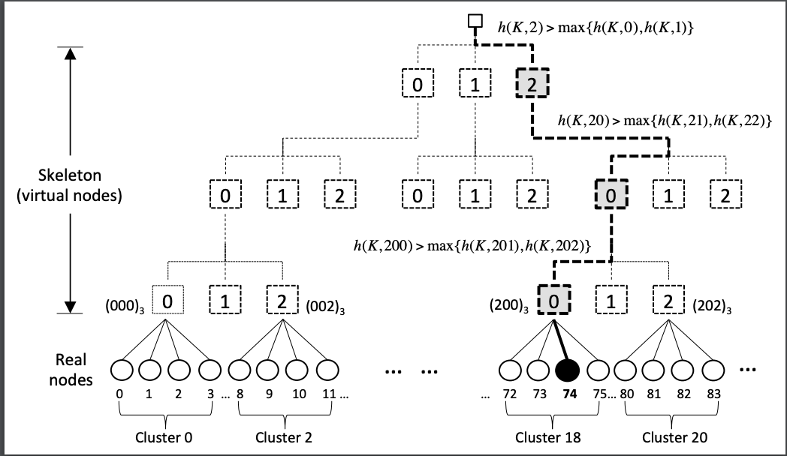

Source: <https://upload.wikimedia.org/wikipedia/commons/3/31/Hrw_skeleton.pdf>

In the accompanying diagram, the cluster size is m = 4. Assuming 120 servers , we get a three-tier virtual hierarchy. Instead of applying HRW to all 120 real servers, we can first apply HRW to the 27 lowest-tier virtual nodes, selecting one. We then apply HRW to the four real nodes in its cluster, and choose the best server based on the best hashing weight. We only need 27 + 4 = 31 hashes, rather than 120.

**Implementation of skeleton based variant**

In the implementation of the skeleton based variant, it requires us to implemented several additional methods to maintain the tree of virtual nodes such as addition of new servers, removal of server and generation of tree. Below is the code to retrieve the target server and application of rendezvous hashing on the selected server of cluster.

When a new server is added or remove, we have to generate the tree again to have a uniform distribution of servers in each branch which is a added complexity associated with this approach.

For the distribution of 1000 keys , there were 16000 comparisons for the normal HRW hashing while it were reduced to 10000 comparisons in case of skeleton based variant of HRW with 2 levels.

**Conclusion**

Rendezvous hashing distributes objects uniformly over all sites, given a uniform hash function with an additional computation of O (n) for each key. When n (servers) is not too large , the computation cost of basic HRW is not likely to be a problem. But for a larger n, we may require to use a variation like skeleton based hashing which subsequently reduced the time.

**References**

<https://en.wikipedia.org/wiki/Rendezvous_hashing>